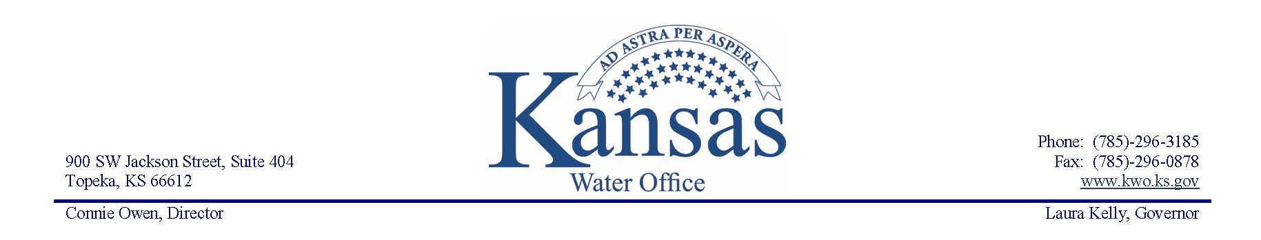

Publication Date: April 26, 2024

For More Information:

Kristin Kaipust

(785) 296-3185, kristin.kaipust@kwo.ks.gov

Kansas Reservoir Protection Initiative Now Accepting Applications

*Lands eligible for assistance to enhance reservoir sedimentation reduction*

The Kansas Water Office and Director Connie Owen, in conjunction with water conservation partners, announces that applications are now being accepted for the Kansas Reservoir Protection Initiative (KPRI).

This program provides financial assistance to landowners in priority watersheds to implement conservation practices enhancing sediment-reducing efforts above federal reservoirs where water supply storage is impacted by reservoir sedimentation. This year, the initiative covers Hillsdale, Perry, Pomona, Kanopolis, Fall River, John Redmond and Tuttle Creek reservoirs. Lands located in targeted sub-watersheds in portions of Atchison, Barton, Butler, Brown, Clay, Coffey, Douglas, Ellsworth, Franklin, Greenwood, Jackson, Jefferson, Johnson, Lyon, Marshall, Miami, Nemaha, Osage, Pottawatomie, Republic, Riley, Russell, Washington, and Wabaunsee counties are eligible for assistance.

Funding for the KPRI was supported by Governor Laura Kelly and the 2024 Kansas Legislature as a part of the full restoration of funding for the State Water Plan Fund to address priority water resource issues and projects recommended by the Kansas Water Authority.

“Our Kansas reservoir system serves as critical source water infrastructure for our citizens during periods of drought and flooding, with this storage being diminished over time by reservoir sedimentation,” said Owen. “Funding through the Kansas Reservoir Protection Initiative provides an opportunity for producers above some of our key federal reservoirs to improve the productivity and health of their lands while also providing benefits to downstream water resources.”

Under the Kansas Reservoir Protection Initiative, the Kansas Water Office, Kansas Department of Agriculture – Division of Conservation, the Kansas Department of Health and Environment as well as the Kansas, Marais des Cygnes, Neosho, Smoky Hill- Saline and Verdigris Regional Advisory Committees collaborate with local Watershed Restoration and Protection Strategy (WRAPS) projects and local county conservation districts to identify priority projects for funding which yield the greatest sediment reduction per state dollar invested.

Landowners interested in participating are encouraged to contact their local county conservation district or Watershed Restoration and Protection Strategy (WRAPS) Coordinator to apply. Many sediment- reducing conservation practices are eligible through this initiative, however, projects focusing on large gully repair and soil health practices such as reduced tillage and cover crops are highly encouraged. Applications for this initial round of funding will be accepted starting June 3, 2024 through the close of business on June 28, 2024. It is not guaranteed that adequate funding will be available to provide financial assistance to all eligible applications.

For additional information, please visit [kwo.ks.gov/projects/kansas-reservoir-protection-initiative](https://kwo.ks.gov/projects/kansas-reservoir-protection-initiative).

###

*As the state’s water office, KWO conducts water planning, policy coordination and water marketing as well as facilitates public input throughout the state.*

*The agency prepares the KANSAS WATER PLAN, a plan for water resources development, management and conservation.*