Minutes

 | KANSAS WATER AUTHORITY
March 9, 2020 | Topeka, Kansas | Conference Call

Call to Order: Chair Connie Owen called the March 9, 2020, Kansas Water Authority conference call to order at 12:00 p.m.

Members Present: Connie Owen - Chair; David Stroberg, John Bailey, Randy Hayzlett, Alan King, Dennis Schwartz, Mark Fischer, Lynn Goossen, Ted Nighswonger

Members Absent: Mike Armstrong, Chris Ladwig, Carolyn McGinn, Jeremiah Hobbs

Ex-Officio Members
Present: Ted Harris (KBS), Dan Devlin (KSU), Earl Lewis, Scott Carlson (DOC), Amanda Reed (KDHE), Ryan Hoffman (KCC), Mike Beam, Chris Beightel, Sara Baer

Ex-Officio Members
ABSENT: Brad Loveless, David Toland, Rolfe Mandel

National environmental policy act (NEPA) Follow up:
Matt Unruh and Connie Owen presented on the Council of Environmental Quality (CEQ) Update to the Regulations Implementing the Procedural Provisions of the National Environmental Policy Act.

Motion No. 03-20-01 It was moved by Connie Owen and seconded by Alan King to approve the draft letter provided to the KWA, pending editorial changes, being submitted as formal KWA comments to the Council on Environmental Quality regarding the Update to the Regulations Implementing the Procedural Provisions of the National Environmental Policy Act if the CEQ does not grant an extension of the comment period beyond March 10, 2020. Motion Carried with no dissenting votes. Information found in Meeting Materials

ADJOURNMENT The KWA adjourned at 1:00pm

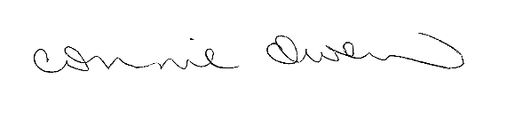
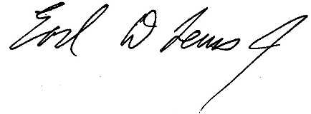
_______________________ ________________________
Connie Owen, Chair Earl Lewis, Secretary

